**School Parent and Family Engagement Plan**

**What is it?**

The School Parent and Family Engagement Plan describes how Carver STEAM will provide opportunities to improve parent engagement to support student learning. Carver STEAM values the contributions and involvement of parents to establish an equal partnership for the common goal of improving student achievement. This policy describes the different ways that Carver STEAM will support parent engagement and how parents can be engaged.

**How is it revised?**

Carver STEAM welcomes parent input and comments regarding this plan are during the school year. The policy is posted on our school Web site for parents to view and submit feedback throughout the year. All parent feedback received during the year will be used to revise the plan for the next school year. We also distribute an annual survey to ask parents for their suggestions on the plan and the use of funds for Parent and Family Engagement. Parents can also give feedback during several parent meetings and activities during the school year.

**Who is it for?**

All parents at Carver STEAM are encouraged and invited to fully participate in the opportunities described in this plan. Carver STEAM will provide full opportunity for the participation of parents with limited English, parents with disabilities and parents of migratory children

**Where is it available?**

At the beginning of the year, the School Parent and Family Engagement Plan is given to all students. As a reminder, a copy will be mailed to each home. Parents can also receive a copy of the Parent and Family Engagement Plan in the on the school’s website.

**The S.T.E.A.M. Academy at Carver**

Parent and Family Engagement Plan for

Shared Student Success

2024-2025 School Year

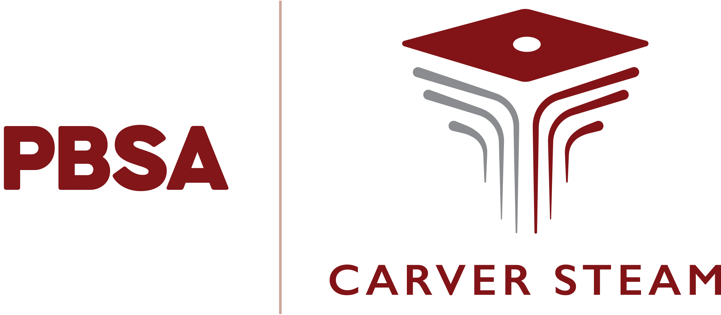

**Niomi Henry, Principal**

55 McDonough Blvd SE, Atlanta, GA 30315

404-802-4415

Plan Revised Sept. 10, 2024

**What is Title I?**

Carver STEAM is identified as a Title I school as part of Every Student Succeeds Act (ESSA). Title I is a federal grant that was designed to ensure that all children receive a high-quality education and reach grade level proficiency. Title I programs must be based on effective means of improving student achievement and include strategies to support parent and family engagement. All Title I schools must jointly develop with all parents a written Parent and Family Engagement Plan.

**School Parent Compacts**

As part of this plan, Carver STEAM and our families will develop a school-parent compact, which is an agreement that parents, teachers, and students will develop that explains how parents and teachers will work together to make sure all our students reach grade- level standards. The compacts will be reviewed and updated annually based on feedback from parents, students, and teachers at various times during the year. The school-parent compacts are kept in the Parent Resource Center.

**Let’s Get Together**

**Open House**

Parents and families will be invited to meet teachers, staff, and community partners. Parents and families will receive pertinent information about what to do to prepare for the school year.

**National Parent Engagement Month Parent Conferences**

Parents will have the opportunity to meet with their child’s teachers to gain firsthand knowledge of their child’s progress. There will be multiple events during the next few months…..Stay Tuned!

**Ahead of the Curve: Preparing for Testing**

Parents will have the opportunity to learn about the SLDS Parent Portal to gain insight into their student’s testing data. Parents and students will be encouraged to set personal goals for the Georgia Milestones utilizing that data. Parents and students will also receive study materials for the GA Milestones exams.

**Parent Café Series: S.O.S “Supporting Our Students”**

Make mental health and supporting school success a priority this year with our COR partner! Parents will learn about SEL “Social Emotional Learning”, Community Resources, and strategies to incorporate into their family routine.

(Sessions will be on campus with COR once a month)

**Title, I Spring Input Meetings**

We will invite parents to our Title I Spring Input Meetings to review and revise our Parent and Family Engagement Plan & the school-parent compacts. Each meeting will be in conjunction with a fun activity for families and students.

**2024-2025 School Goals**

Overall Goal: By the end of the school year 2024-2025, Carver STEAM will yield a **10%** increase in the Proficient category on Georgia Milestones EOCs.

Targeted Goals:

**9th grade**: **10%** increase in the Proficient Category on 9th grade Literature and Composition EOC

**10th grade**: Yield a **10%** increase in the Proficient Category on Geometry EOC

**11th grade:** Yield a **10%** increase in the Proficient Category on American Literature EOC

**12th grade:** Yield an **80%** increase in graduation rate

**Parent and Family Engagement**

Carver STEAM believes that Parent and Family Engagement means the participation of parents in regular two-way and meaningful communication involving student achievement and other school activities, including ensuring:

• Parents play an integral role in assisting their child’s learning

• Parents are encouraged to be actively involved in their child’s education

• Parents are full partners in their child’s education and are included, as appropriate, in decision-making to assist in the education of their child

Effective Parent and Family Engagement will not be an occasional event, such as a parent/teacher conference; instead, it will be an on-going process. Please contact our Parent Liaison for additional information:

**Ms. Shambril Manago**

**Office: 404-802-4410**

**Cell: 470-593-6774**

**Email: smanago@pbsatl.org**

**Share Your Thoughts!**

We want to hear from you. If you have any suggestions or if there is any part of this plan that you feel is not satisfactory with the student’s and the school’s goals for academic achievement, please provide us with your comments in the space provided and return this form to **smanago@pbsatl.org**

Parent Name: _____________________________________________________

Email Address: _____________________________________________________

Phone Number: _____________________________________________________

Comments and Suggestions: ____________________________________________________________________________________________________________________________________________________________________________________________________________________________________________________________________________________________________________________________________

**Carver STEAM is Branching Out!**

Carver STEAM will take the following measures to promote and support parents as an important foundation of the school to strengthen the school and reach our school goals.

**We will:**

Provide parents of participating children with timely information about the Title I program by inviting parents to attend the parent meetings and conferences via website/flyers, written correspondence, ROBO calls, and advisory teachers phoning parents in a language parents can understand.

Provide grade level meetings for parents hosted by the school counselor and the parent liaison to offer information on middle to high school transition (8th grade to 9th grade) and high school to college (12th to college) transition.

Provide assistance to parents in understanding the state’s academic content standards, how to monitor their child’s progress and how to work with educators by inviting them to attend our annual orientation meeting and to a flexible number of workshops as well as offering valuable resources throughout the school year.

Encourage parents to be involved in the decision-making process by sending out invitations for meetings regarding annual school goals, academic activities, etc. We will also ensure that information related to the school and parent programs, meetings and other activities is sent to the parents in an understandable format including newsletters/ flyers, written correspondence, ROBO calls and direct phone calls.

Update the School Parent and Family Engagement Plan periodically to meet the changing needs of parents and the school and ensure that it is properly distributed or available to parents, the local community, and the school staff.

Interested in joining the Principal’s Parent Advisory Board? Return this form to **smanago@pbsatl.org**

Name: ____________________________________________________

Email Address: ________________________________________

Phone Number:_________________________________________

